Question # 1
Tick the correct option
1. | If x = 0 and y = 0 then $θ=$
a. | 90 |  |  | b. |  | -90 |  | c. | 0 | d. |  | Undefined
2. |  | What is true about modulus of a complex number:
a. |  | $$\left|z\right|>0$$ |  | b. |  |  | $$\left|z\right|≥0$$ | c. | $$\left|z\right|∈R$$ | d. | None of these
3. |  |  | Cartesian form of the complex number (5,275)
a. |  |  | (-4.4,-1.257) | b. | (0.087,0.99) |  |  | c. | (-0.087,-0.99) | d. | (0.44,-4.98)

Question # 2
Answer the following
1. | Express the following complex numbers in polar form: $\frac{1}{2}+\frac{\sqrt{3}i}{2}$
2. | Express the following complex numbers in polar form: $\frac{1-i}{1+i}$
3. | Convert in catesian/rectangular form: $\left|z\right|=\frac{10}{3},\arg\left(z\right)= -\frac{17π}{12}$
4. | If z1 and z2 are two complex numbers then show that : 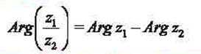
5.
6.
7. | 
8. | 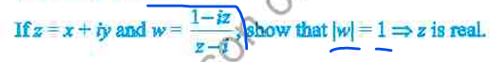
9.
10. | 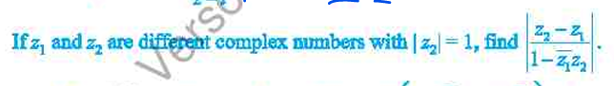

Question # 5
Long Questions
1. | 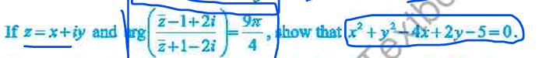
2.
3.

